Linear Regression
Linear regression is used for finding linear relationship between target and one or more predictors. There are two types of linear regression- Simple and Multiple.
Simple Linear Regression
Simple linear regression is useful for finding relationship between two continuous variables. One is predictor or independent variable and other is response or dependent variable. It looks for statistical relationship but not deterministic relationship. Relationship between two variables is said to be deterministic if one variable can be accurately expressed by the other. For example, using temperature in degree Celsius it is possible to accurately predict Fahrenheit. Statistical relationship is not accurate in determining relationship between two variables. For example, relationship between height and weight.
The core idea is to obtain a line that best fits the data. The best fit line is the one for which total prediction error (all data points) are as small as possible. Error is the distance between the point to the regression line.
Linear Regression Model Representation:
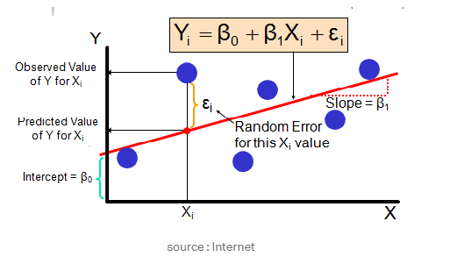
In higher dimensions when we have more than 1 input variables the line is now replaced by
a plane or hyper plane.
Real-time example
We have a dataset which contains information about relationship between ‘number of hours studied’ and ‘marks obtained’. Many students have been observed and their hours of study and grade are recorded. This will be our training data. Goal is to design a model that can predict marks if given the number of hours studied. Using the training data, a regression line is obtained which will give minimum error. This linear equation is then used for any new data. That is, if we give number of hours studied by a student as an input, our model should predict their mark with minimum error.
Y(pred) = b0 + b1*x
The values b0 and b1 must be chosen so that they minimize the error. If sum of squared error is taken as a metric to evaluate the model, then goal to obtain a line that best reduces the error.
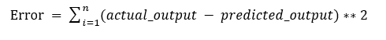
Error calculation
If we don’t square the error, then positive and negative point will cancel out each other. For model with one predictor,
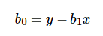
Intercept Calculation
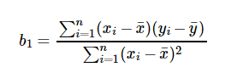
Co-efficient formula
Exploring ‘b1’
- If b1 > 0, then x(predictor) and y(target) have a positive relationship. That is increase in x will increase y.
- If b1 < 0, then x(predictor) and y(target) have a negative relationship. That is increase in x will decrease y.
Exploring ‘b0’
- If the model does not include x=0, then the prediction will become meaningless with only b0. For example, we have a dataset that relates height(x) and weight(y). Taking x=0(that is height as 0), will make equation have only b0 value which is completely meaningless as in real-time height and weight can never be zero. This resulted due to considering the model values beyond its scope.
- If the model includes value 0, then ‘b0’ will be the average of all predicted values when x=0. But, setting zero for all the predictor variables is often impossible.
- The value of b0 guarantee that residual have mean zero. If there is no ‘b0’ term, then regression will be forced to pass over the origin. Both the regression co-efficient and prediction will be biased.
Co-efficient from Normal equations
Apart from above equation co-efficient of the model can also be calculated from normal equation.

Co-efficient calculation using Normal Equation
Theta contains co-efficient of all predictors including constant term ‘b0’. Normal equation performs computation by taking inverse of input matrix. Complexity of the computation will increase as the number of features increase. It gets very slow when number of features grow large.

References:
https://medium.com/@srishtisawla/linear-regression-data-science-algorithm-every-data-scientist-should-know-34d5fcb51c03
https://www.statisticshowto.com/statistical-relationship/
https://towardsdatascience.com/linear-regression-detailed-view-ea73175f6e86

